HUMAN FACTORS AND THE USER EXPERIENCE

ROAD SCHOLAR
Roadscholar.org is a not-for-profit experiential learning tour company. Roadscholar’s primary customers are people over the age of 50 who want to have an educational travel experience. The user’s goal is that they need an easy way to see, learn and purchase an educational trip. They will probably be making plans and purchases at home or at their workplace. They can plan and purchase on a mobile device, but this report will focus on a desktop experience.

Outcome: User success will be measured on how easily they can find information about a trip and make a purchase.

SENSORY SYSTEM
Roadscholar uses red (#D32226) as their primary brand color, with blue being the primary button color, although some buttons are red. In regard to Sensory Systems, one of the biggest issues seen here is CONTRAST. On the home page, we see a red button over a photo. However, this doesn’t provide a lot of contrast, especially for the 50+ audience. In addition, an online WCAG AA contrast test showed that the button contrast failed against the background. What almost redeems this is that the form in the header will bypass the red button when you start entering in information. In any case, since the background and the button do not have enough contrast, a simple fix would maybe make the button white or similar light color, round the corners, and add a border around the button and/or drop shadow, to let the user easily see this button.
The button here does not have enough contrast against the background
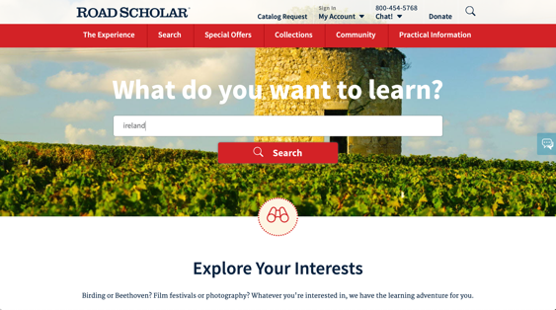

The biggest contrast violation would be, though, once you click on a trip, right under the H1 of the page, there are dark blue buttons, which act as “filters” for other trips. These buttons are usually over dark photos, so these really suffer from a lack of contrast. White buttons would probably solve this, with a border or drop shadow as needed.
The buttons here do not have enough contrast against the background
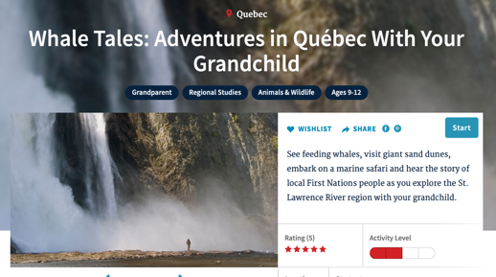

PRE-ATTENTIVE PROCESSING
On the home page, one can see that there is a GROUPING – a shape of a triangle. What this shape does is that it guides the eye from the top down to the bottom of the page. While for the most part, this is good, because it will hopefully encourage the user to fill out the form element and click search, however, one issue is that it makes the “binoculars” icon a focal point. The binoculars icon is a button and there isn’t enough affordance to suggest that it is. Clicking on the binoculars takes you to the “Road Scholar Collections” page, which doesn’t explain what a “Collection” is. It can be assumed that there is a business reason to send users to this page, however it would be good for the user to know why they are going to the “Collections” page. Perhaps because of the directional arrow pointing down, users will continue to scroll down the page and see other programs and trips.
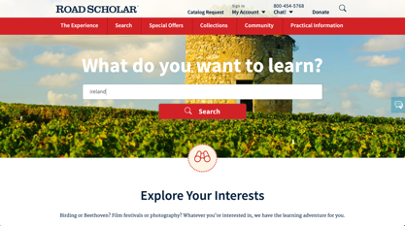

MENTAL MODELS
The homepage uses EXISTING/PRIOR KNOWLEDGE — because the users are often retired and have disposable income to pay for these trips, it can be safely assumed that they have purchased online travel. The Roadscholar site very similar to other popular travel sites, such as Booking.com, Expedia, and Priceline.com. Perhaps Roadscholar has an advantage here as the first input they require is just a location or interest, while other travel sites require dates, number of passengers, departing location, arriving location, etc.
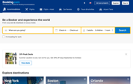
Booking.com
Priceline.com

Expedia.com

COGNITIVE SKILLS
The users/customers of Roadscholar.org are mostly college educated and have disposable income that will allow them to afford an educational tour. The user’s cognitive abilities most likely as such: Field Independent, Reflective, and Self-Guided. We can’t be sure if they are Holistic/Serial or Visual/Verbal. In any case, for the users who Field Dependent, Impulsive, or Externally Guided, all the pages have a prominent phone number and chat where a phone agent can walk them through their trip options and purchase.

One issue that was observed in this matter is that all the pages have a chat icon on
the right side of the page. When one clicks this button, it opens a modal that ask
for “feedback on improving our site.” The icon should probably be changed to
something else because it makes an Externally Guided or Field Dependent user think
they will be able to use this to chat with a sales person, not someone on the UX team.

MEMORY SYSTEMS
Roadscholar.org does a good job making use with the working memory principle. When a user starts typing into the form in the top of the page, the site automatically starts presenting three trip options, which is below the 4-7 chunks recommended.

As an example, a user starts typing in “Ireland”. As soon as the letter “I” is typed in, the user is presented with three trip choices. As the user continues to type in, the trips change to better reflect the word being typed. It also gives you options on the side, in case you don’t want to finish typing your word, misspelled a word, or see another trip that you might be interested in. Additionally, there are radio buttons under the three trips that allow you to see another three trips offered.

One issue in terms of memory is in the search menu, they give the option to search by program number. Most users are not going to be able to remember this; this is a seven-digit number that is not easy to find. The user would probably need to be given the number over the phone by a sales person or find it on the site. This is a minor issue and there may be a reason it’s there that isn’t apparent.

EMOTIONAL/MOTIVATION/ANXIETY
Roadscholar.org is good at walking people through the process of choosing a trip, reducing anxiety. The user starts to type in form on the homepage, choose a trip, then sends the user to the trip page. The user is given the choice of dates. In four clicks, a user will have chosen a trip.

On a trip page, Roadscholar also gives the sales number three times, in case the user wants to have someone walk them through the purchase. The salesperson can take credit cards over the phone or give them instructions on how to pay for the trip with a mailed in check. Some older users may be cautious about using their credit card on a website, so this option can help alleviate their fears.

One issue is that, after they choose their trip on the site, a new user is required to create an account. The user isn’t told why they are being asked to create an account, which could cause anxiety with users. In order to alleviate those fears, under the headline “Create an Account”, Roadscholar could have a clearly defined value proposition, like “Get Personalized Trip Info”, “Get Exclusive Offers”, or “Continue on Your Journey of a Lifetime”. By giving the user an offer or encouragement, they would hopefully be motivated to continue the process of purchasing a trip. Having a Privacy Notice link might also be helpful to calm anxiety.

CONCLUSION
Roadscholar.org overall has a good website experience when it comes to human factors. Users have two routes to booking a trip, either by a simple web interface or by calling a friendly phone agent. Especially with an older user, they may appreciate being able to talk to a human. The biggest issues would be contrast with the buttons and the confusing chat button on the side.

